**P3 – Design an event driven application to meet defined requirements**

**Introduction**

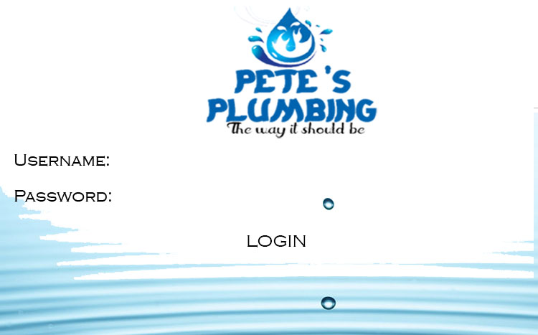In this report, I will be designing the system. Each form will include a login screen, main form, and screen help. Each one is different, and it is designed to help the user. This is designed to be suited and meet the requirements of the plumber.

**Login Screen**

The first thing that the user will do is these details. No other screen will appear until the user has entered these details. This is how the login screen will roughly look like, when it has been complete. The main aim of the login screen is for security purposes. Firstly, the user will need to insert his username for him to login and erase any errors for it to be done. Any incorrect password will not allow the user to go to the main form. The button is there for the user to be referred to the main form. The background is specific wallpaper that goes with the unique logo. This unique logo was made separately.

**Main Form**

Unique designed logo

**RULE**

Labour @ £40 / hr.

Travel @ £1 / mile

Plastic pipes @ £2 / m

Copper pipes @ £3 / m

Chrome pipes @ £4 / m

**OUTPUT**

Estimated labour – length of time & cost

Estimated travel – distance & cost

The selected pipes – required lengths & cost

LABOUR X HOUR = £0.00

TRAVEL X MILE = £0.00

PLASTIC PIPES X METRE = £0.00

COPPER PIPES X METRE = £0.00 CHROME PIPES X X METRE = £0.00 Overall Cost:

VAT at 20%

Total Cost with VAT

Discount at 5% if total> = £500

Total after discount:















CALCULATE

RESTART

HELP SHEET

SUBMIT

This is the main form. This is where all of the calculations are complete. As you can see, each section helps Pete to erase any errors. This is just a prototype, and changes can be made whilst the program can be made. They are four buttons on this form. The calculate button calculates what has been typed into the textboxes. The restart button clears all of the numbers that has been entered and calculated. Submit button gets all of the completed calculations and converts it to an excel spreadsheet. This helps the user has he can save the submitted calculations and he cannot lose any of it. The separate section on the top-left is a rule box that helps the user. The last button is Help Sheet. This obviously helps the user. If he/she gets stuck whilst using the program, he/she can click this button for help.

**Help Sheet**

**Help Sheet**

Each step would show you how the whole program works

**Step 1:** Enter username and password to use Pete’s plumbing password.

**Step 2:** Fill in the fields that are required

**Step 3:** Fill in the labour, then how many hours are required

**Step 4:** Enter a number for the travel. You have to fill in all of the fields, so that you can move forward

**Step 5:** Once all of the fields are complete, click the calculate button to do all the calculations.

**Step 6:** If any errors are displayed, or any missing fields, you have to go back and complete them.

**Step 7:** The grand total of it will be displayed.

**Step 8:** You will be referred to a Microsoft Excel spreadsheet, and this would be a completion of what you have entered. You can save the document.

**Any other enquires or problems with the program:**

**Email:** [help@petesplumbingservice.com](mailto:help@petesplumbingservice.com)

**Phone Number:** 0205 524 1942

This is the help service that is required, if any assistance is needed for the user. This shows a step-by-step guide for the user to get help. All of the steps that are shown, it shows each of what is going to happen throughout the program. The details below it shows that if this help is not helpful, he can contact them through email and phone number.

**Flowchart – Login Screen**

**Successfully Entered to the Service**

**Unable to Login**

Y

N

Username Correct?

IF >3

**Enter Password**

Y

N

**Incorrect Username**

**Incorrect Password**

N

**Enter Username**

Y

In this flowchart, it shows the login process of the program that is going to be made. It shows that if the password is incorrect three times, it will be made unavailable to login to the services. It shows that if the user has logged in with the correct details, he can use the services successfully.

**Flowchart – Quotation Form**

In this flowchart, this demonstrates how the main form will be looking like. It shows that once all the information has been entered, it calculates it displays it, and converts it into a Microsoft Excel spreadsheet for the user to save. Converting this to an Excel spreadsheet will get the user to save it. He can organise it. Therefore, each time he uses it, he can put the date it.

**M3 - Explain any constraints on the system design**

**Introduction**

In this report, I will be explaining the constraints of the system. The constraints of the system is costs, organisational policies, timescale, legacy systems and available hardware platform.

**Costs**

Costs of the system requires the plumbing company to think about how much they are willing, or going, to spend. This could be a limitation on the company, because if the plumber has a limited budget, he may not be able to pay the developer. The manager for the business needs to make sure he has enough money as well. If the plumbing company is looking to make a new program from scratch, they need to figure out all of the programs that they would want. Before all of it, they need to think about the cost of the internet, and where it will take place. In other words, they are a lot of things that they need to think about. Not any of them has to be left, because it could cause the company problems. The cost for the plumbing is important, because he will need to get orders in order to get business going.

[](http://www.google.co.uk/url?sa=i&rct=j&q=&esrc=s&frm=1&source=images&cd=&cad=rja&docid=Yaoa5hx06DmOAM&tbnid=aE2NzCGKEd7U1M:&ved=0CAUQjRw&url=http://ljsilentg.com/tag/organisational-policies/&ei=x2OcUpzXIMvQ7AbL_ICoDg&bvm=bv.57155469,d.ZGU&psig=AFQjCNFX5ApoM9S2Ao3D2mfdeXMrG1kpjg&ust=1386067259123562)**Organisational Policies**

These policies are guidelines of what they expect each employee to do or behave when using the system. For example, every user has to be able to log in. For only authorised users to log in to the system should be allowed. Organisational policies are very important for any companies. This may determine what they may use and what they may not use. I think organisational policies should be set for this business, because they will be more work going on if it was not set out.

**Timescale**

Timescale, for computing, plays an important role for the new plumbing system. For any developer, he/she will need to take time to develop and maintain it. For the program that I am going to make for the plumbing service, it is going to take time to make for a month. This is, because errors and changes can be made during the process. A program for the plumber is not going to take a week to make. During the process, the plumber can use a prototype and if the plumber feels that some of the features are not right, the developer can change it.

**Legacy Systems**

Legacy systems is an old program or computer that is outdated. The term “legacy” often refers to old, and it has been used. The constraint for this is that old systems are slow and they are not as good as the updated ones that are out there. For example, the current manual system is being referred to as a legacy system. This system is slow and the manual system is paper-based. This new system will provide the user to store safely and it will be secure.

**Available hardware platform**

Available hardware platform simply means the specific hardware that is needed to continue with the plumbing system. This is crucial part of the process, because any person or group members need the right hardware. If they bought the wrong hardware, they need to replace it. This could cost money. For the plumber, the available hardware that he will have is only a laptop, and he only uses it for himself. He will need another laptop for the program use, as this program is going to be made on Visual Basics. He needs Visual Basics for it the user to continue with it.

**Event procedures and descriptions**

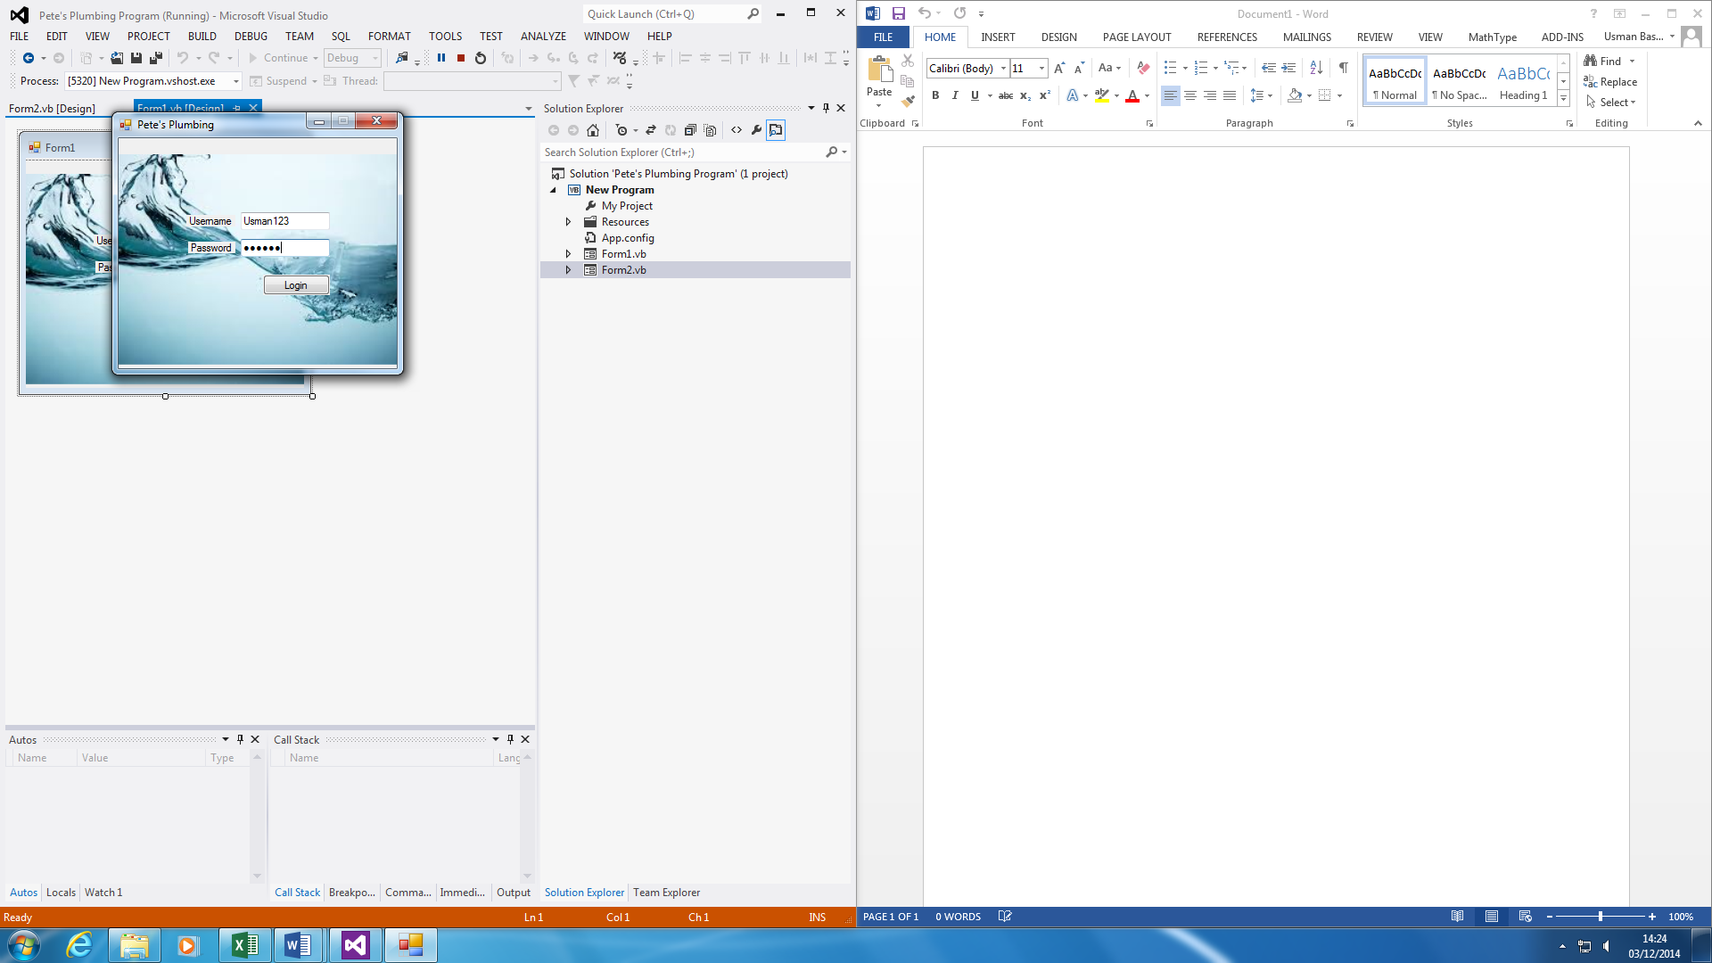

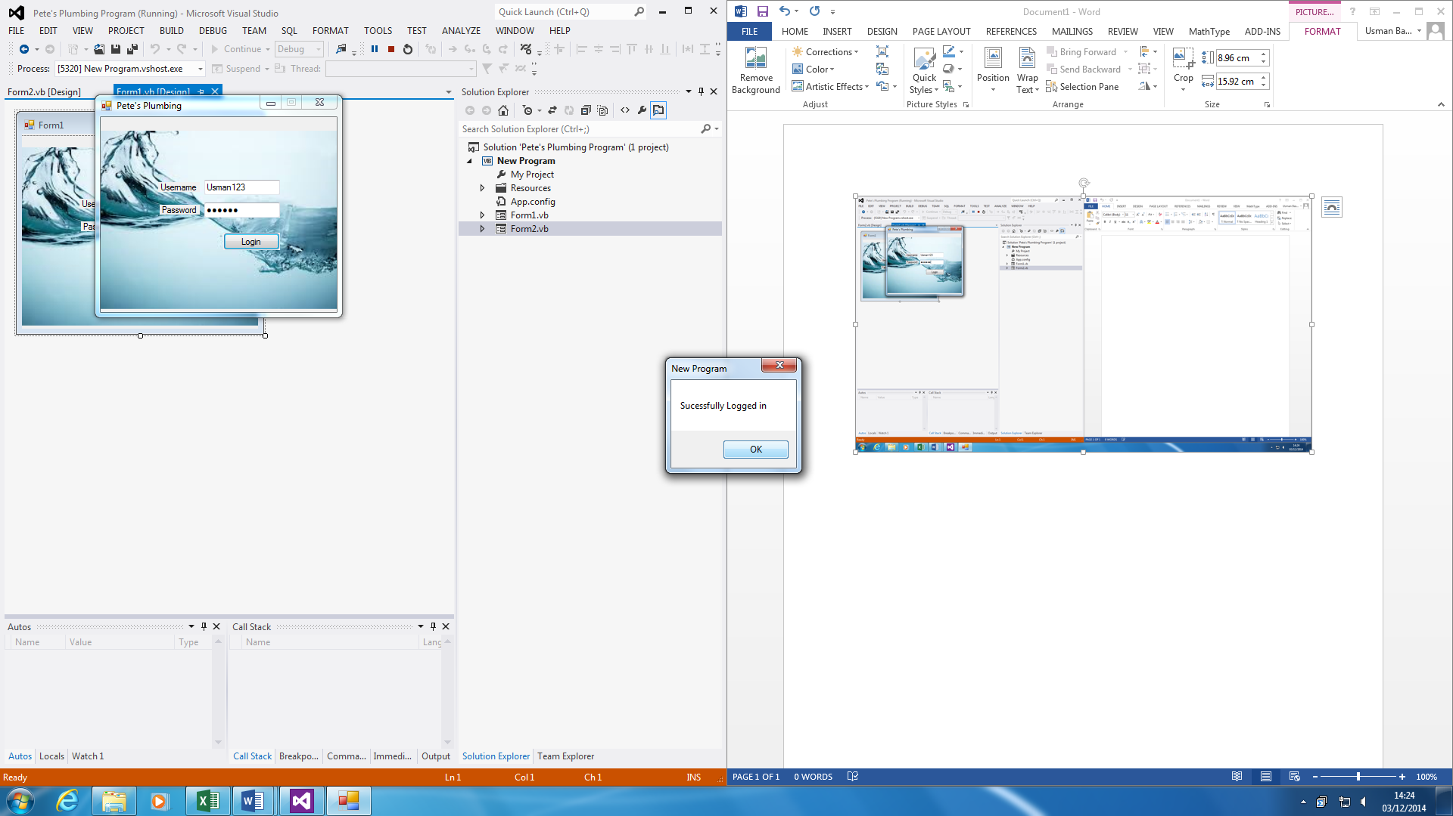

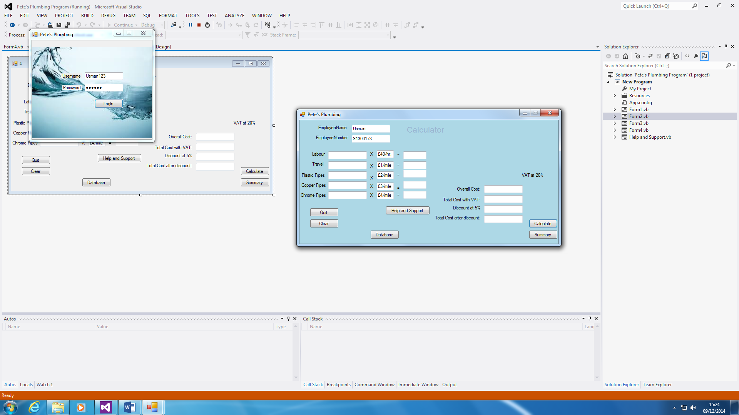

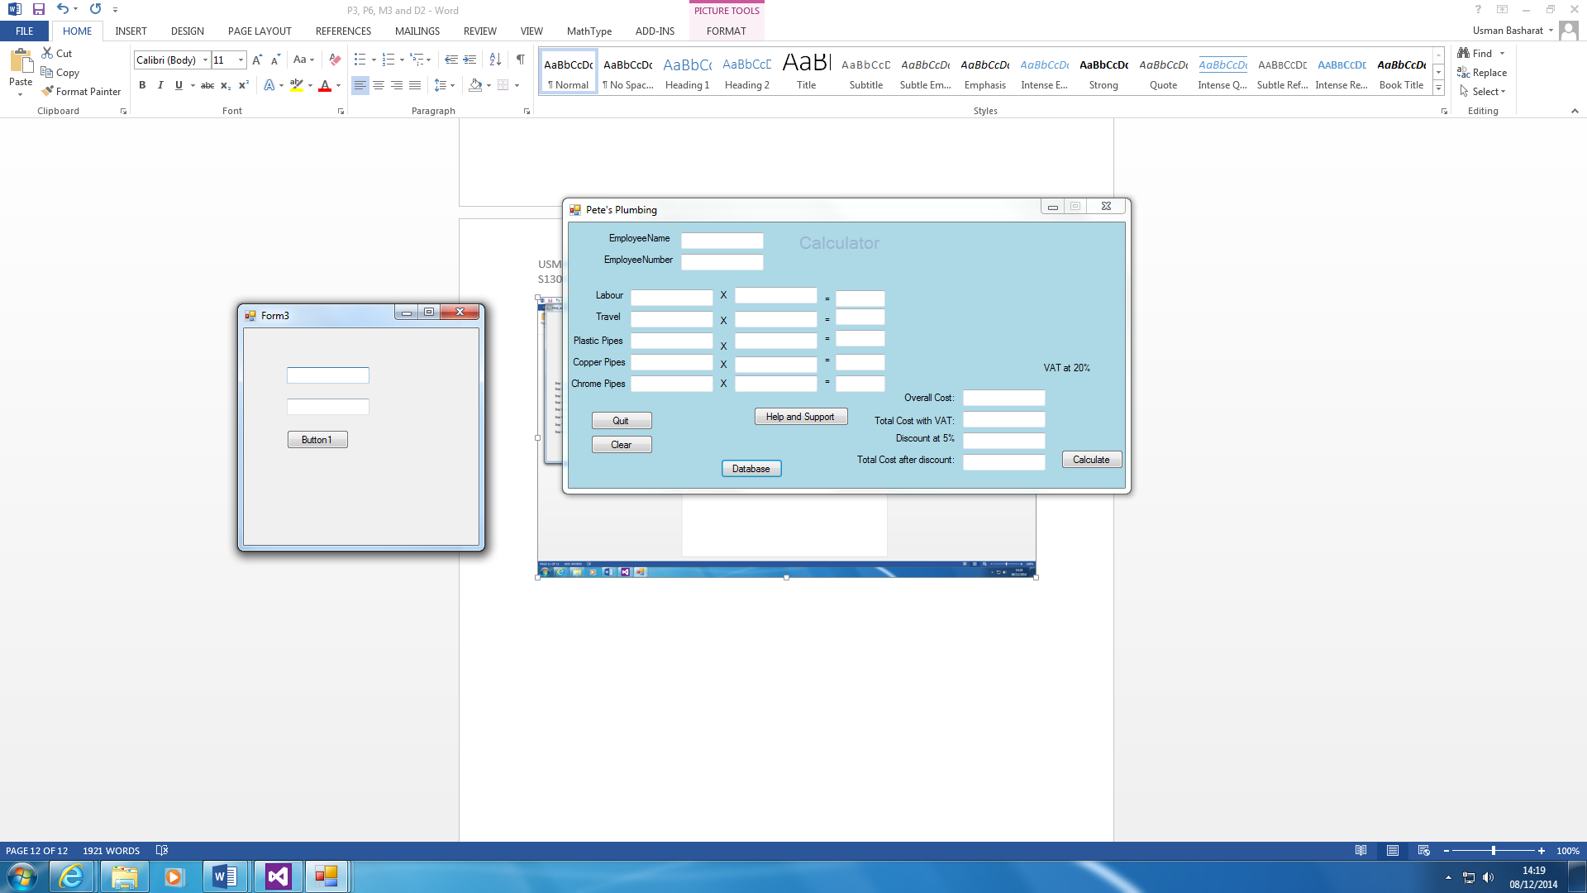

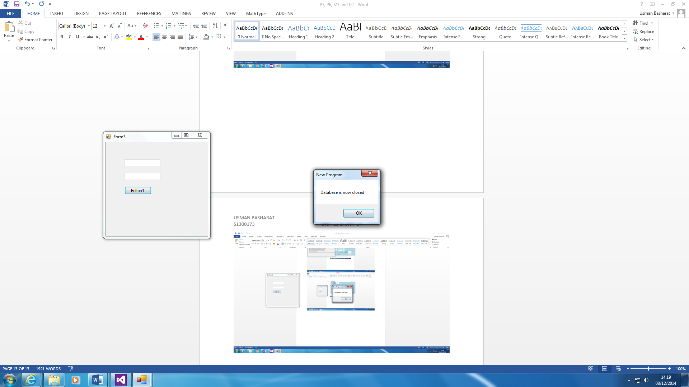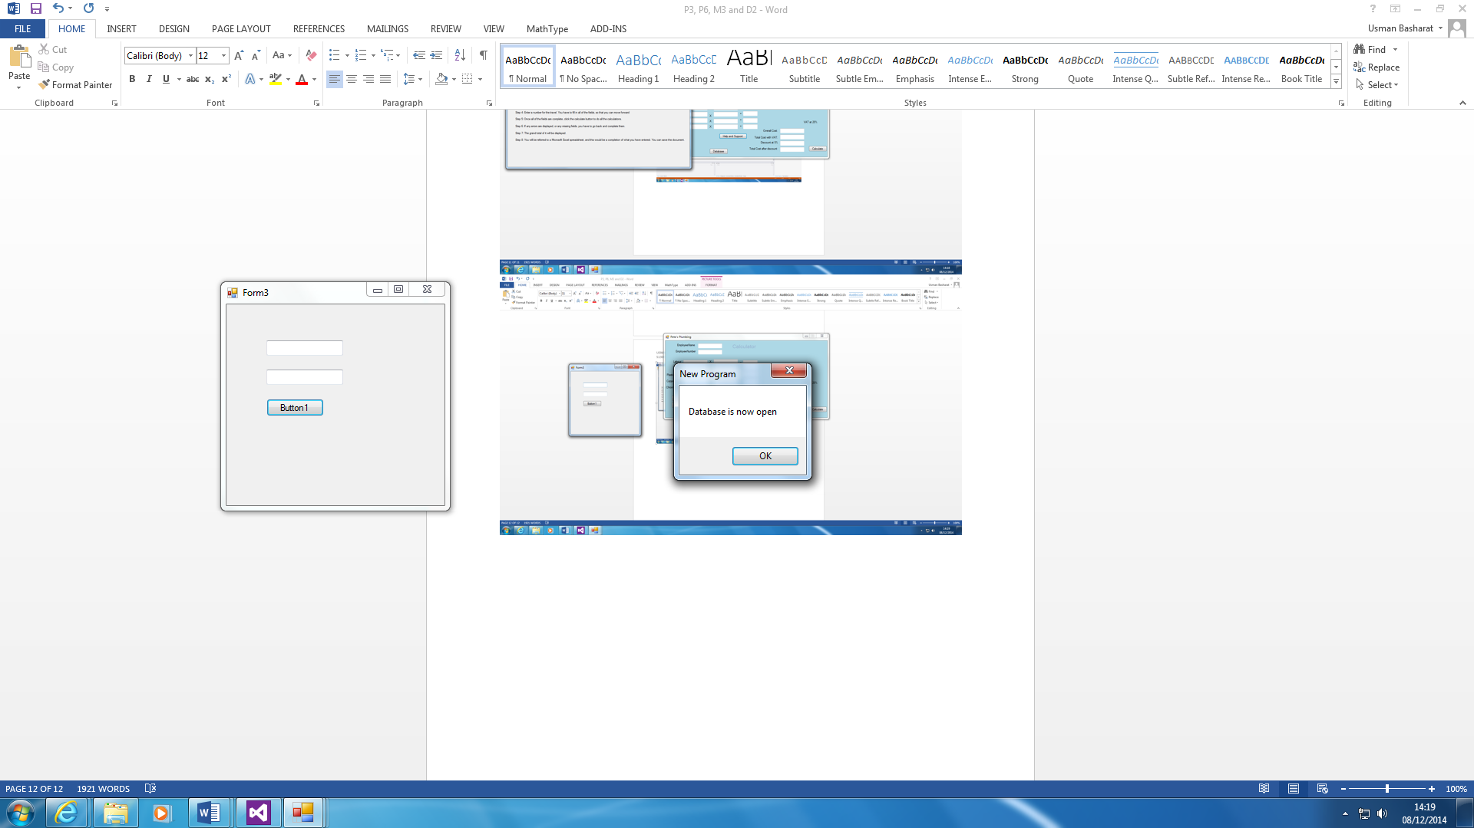

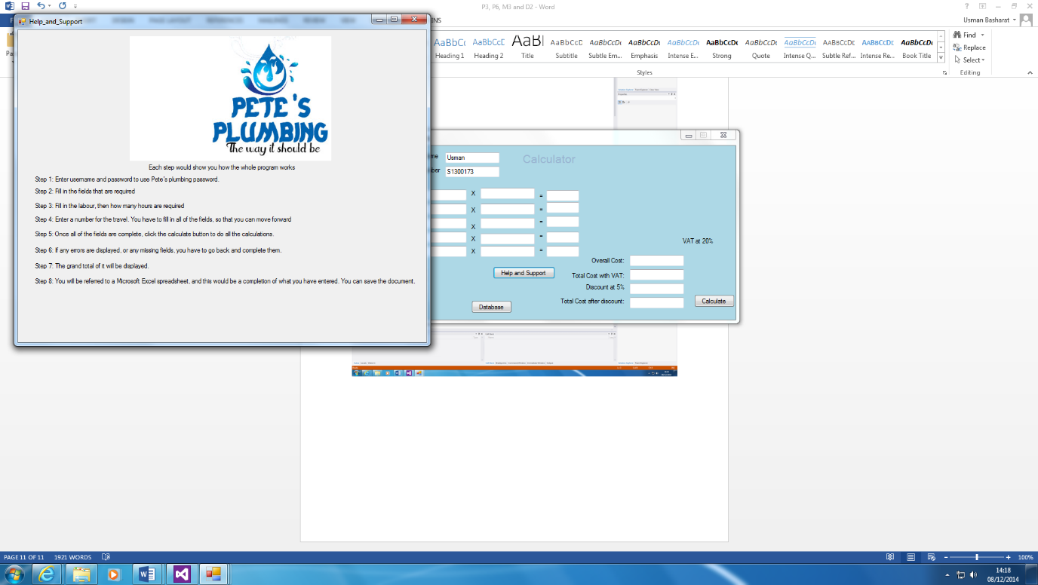

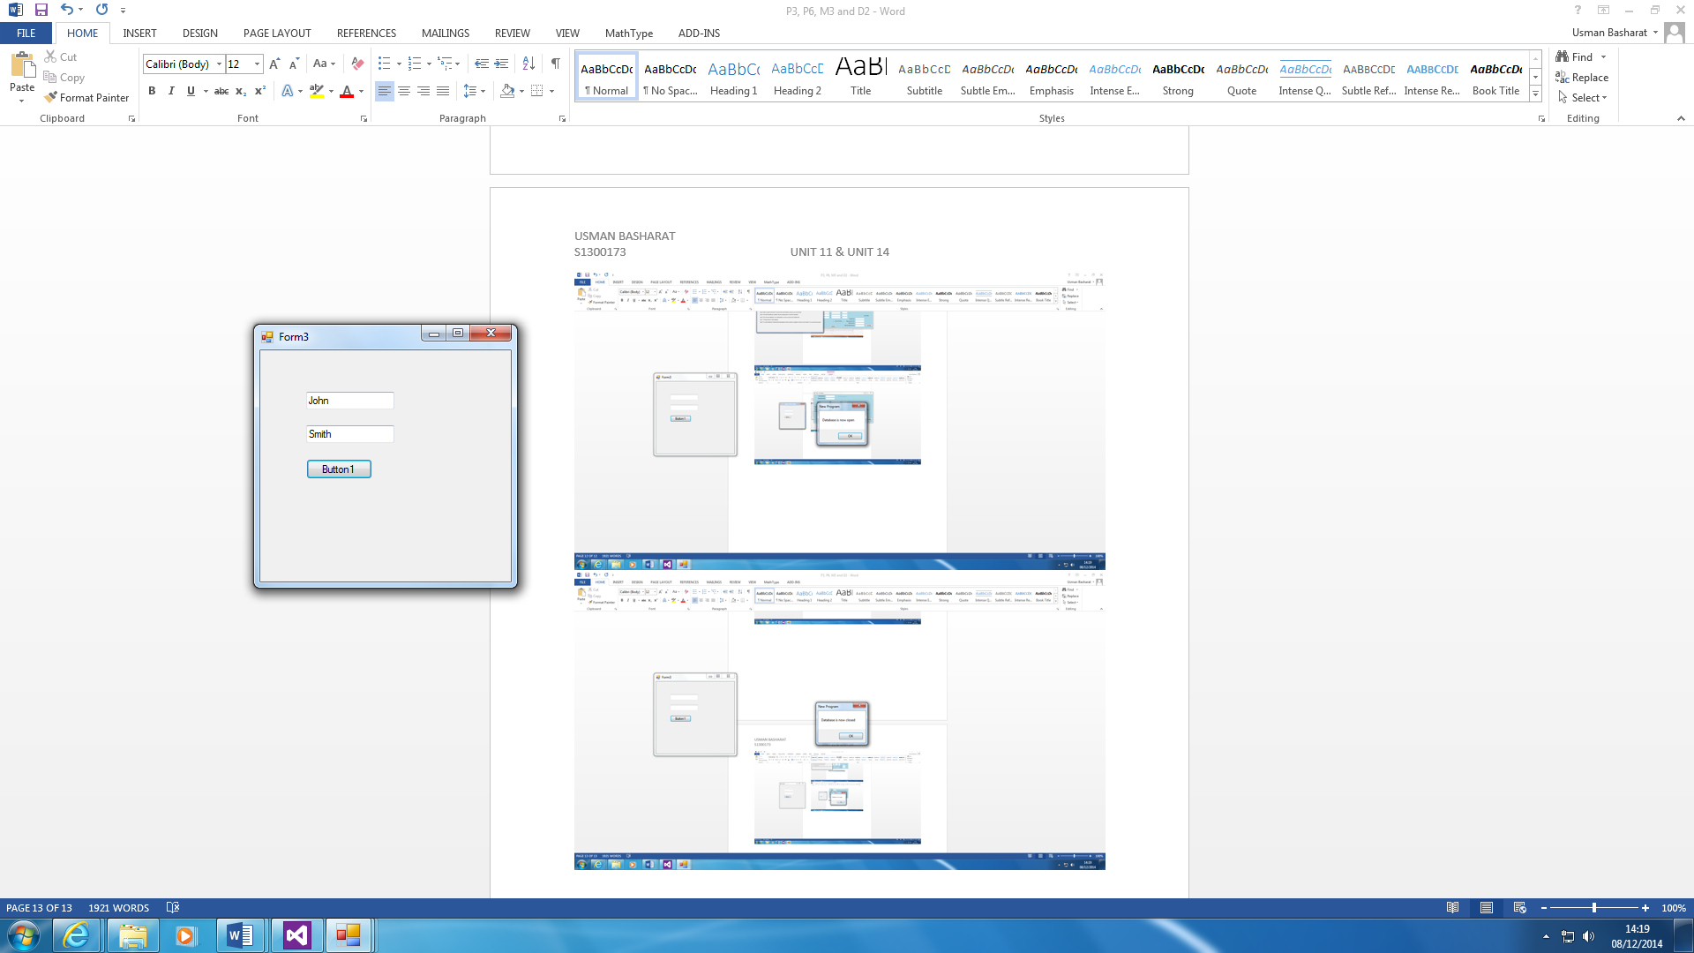

This program helps to erase the plumber’s errors that he was making before. All you have to do is enter the Labour, Travel and Pipes. It calculates it all for you by clicking the calculate button. It shows the VAT percentage and the discount of it. The discount only applies if the user total cost is above £500. If less, it would not work. This is important and as you can see, the discount is at 5%. Then, if any assistance is needed, you can click ‘help and support’ button. This will show a systematic guide of how the program works. If you want to quit the application, you can click on the button to quit it once you are done.

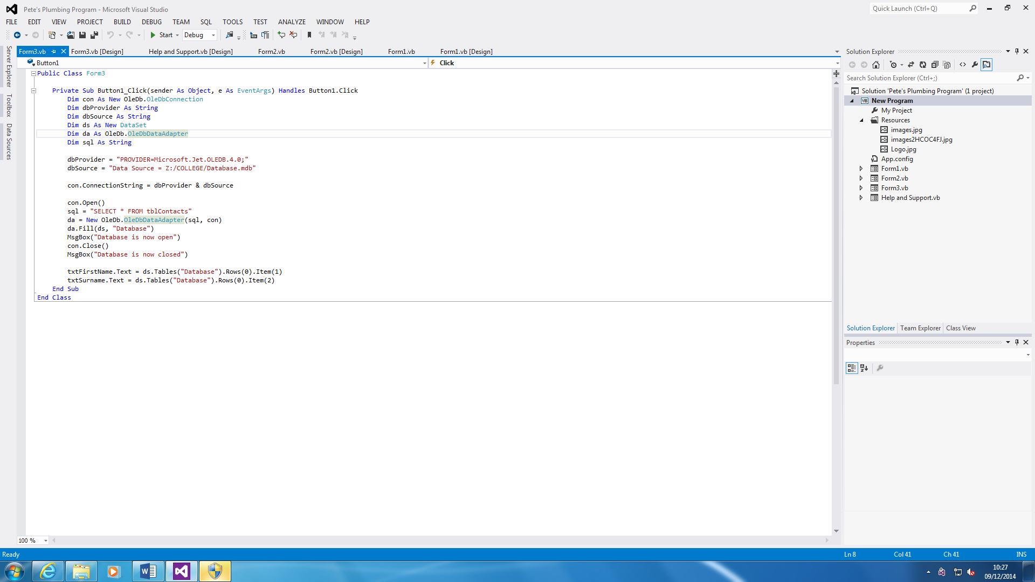

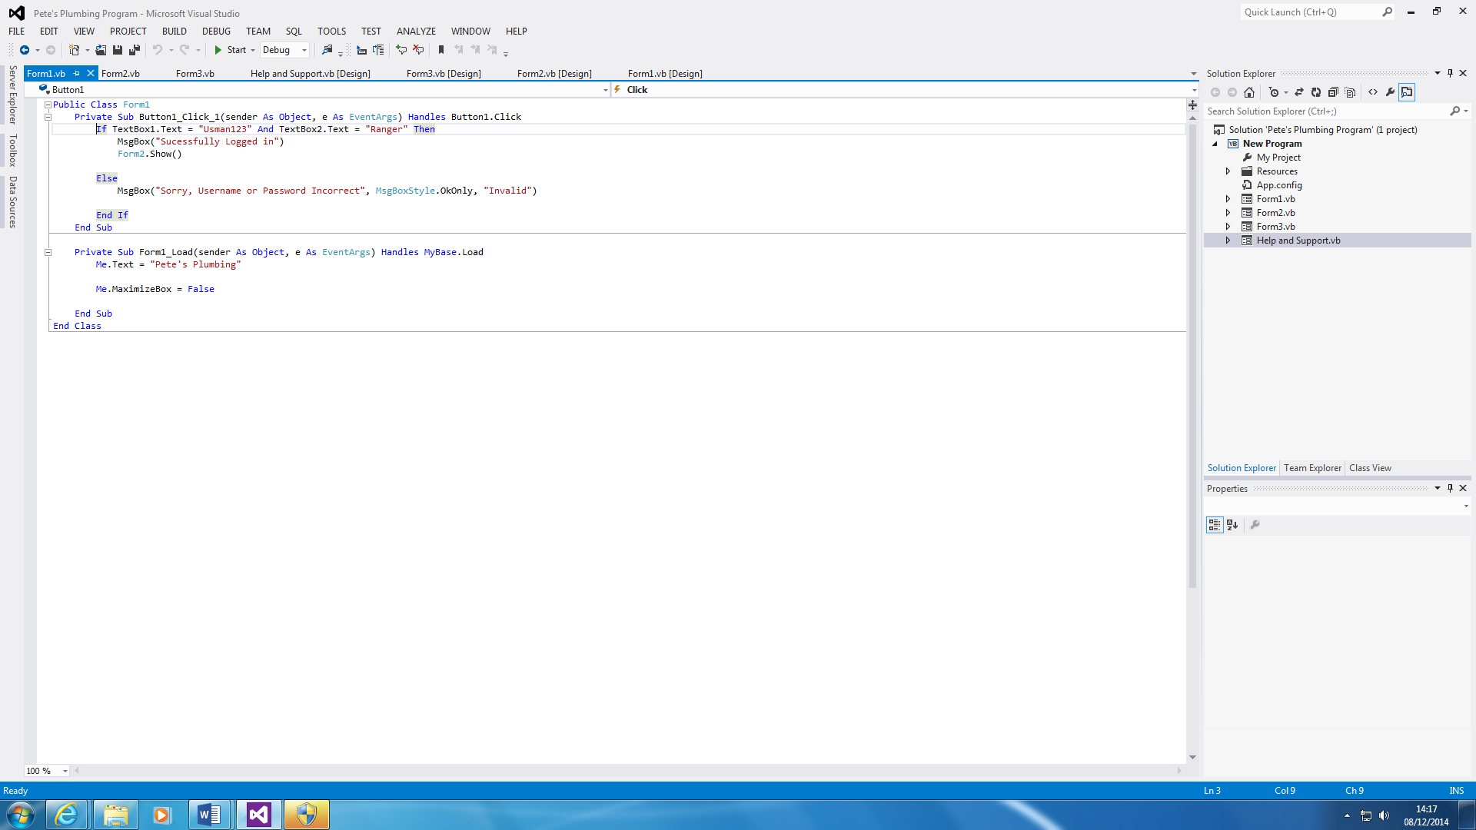

This shows the log in program and the database. The login in is simple. Once it is successful, you can log in to the main form. However, if it is not successful, the user cannot log in to the main form. The database (first) shows that once the database is open, it get the information, and closes the database.

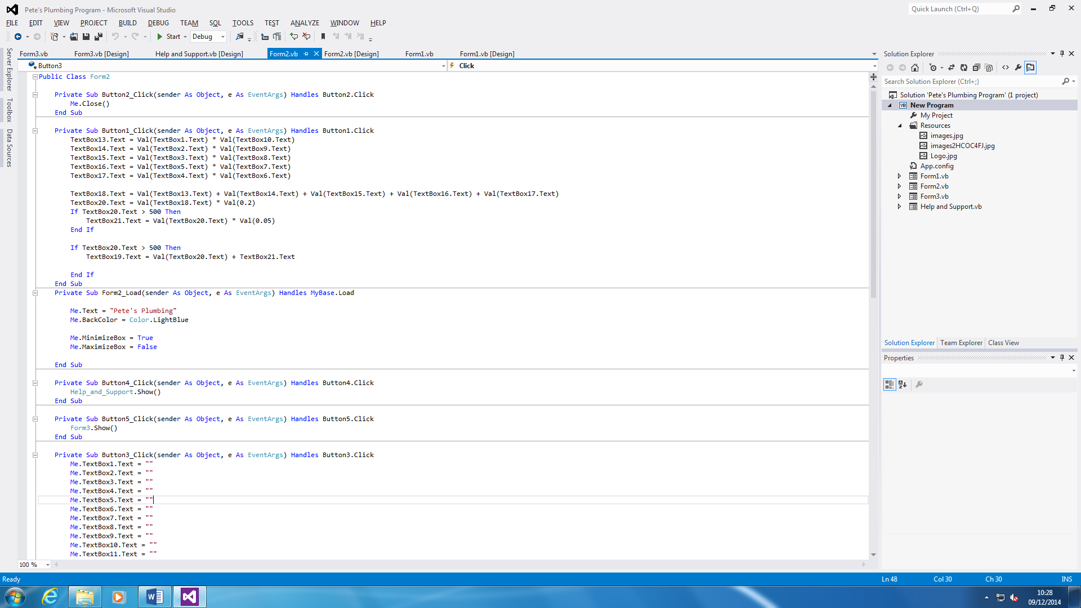

This is the code for the program. This shows how the program is made. Each of the section shows a different side of the program. The first part closes the form. The second part is the calculations of what the use types in to the system. This is when the user types in what he wants and it does it for you. The third part is the colour and the text at the top of it. The colour is light blue and I put the program to do that the person cannot maximise the whole program. He can only minimise it. The last part is once the help and support button is clicked, the form will be displayed. As you can see, it shows the ‘Help and Support’ button with the ‘Form3’. The last part is that so it clears all the textboxes.

**Reference**

<http://en.wikipedia.org/wiki/Legacy_system>

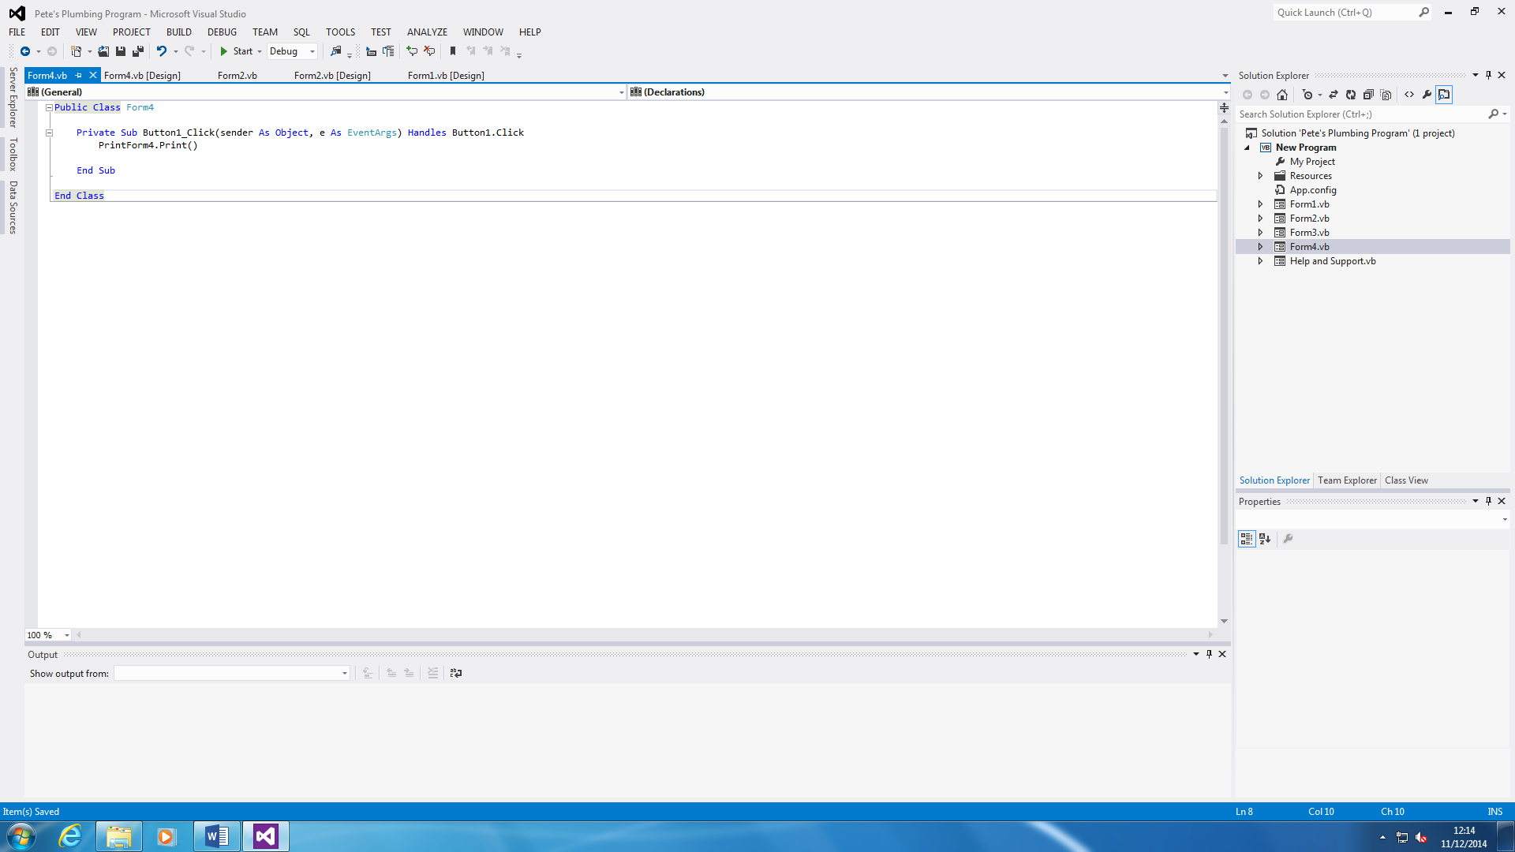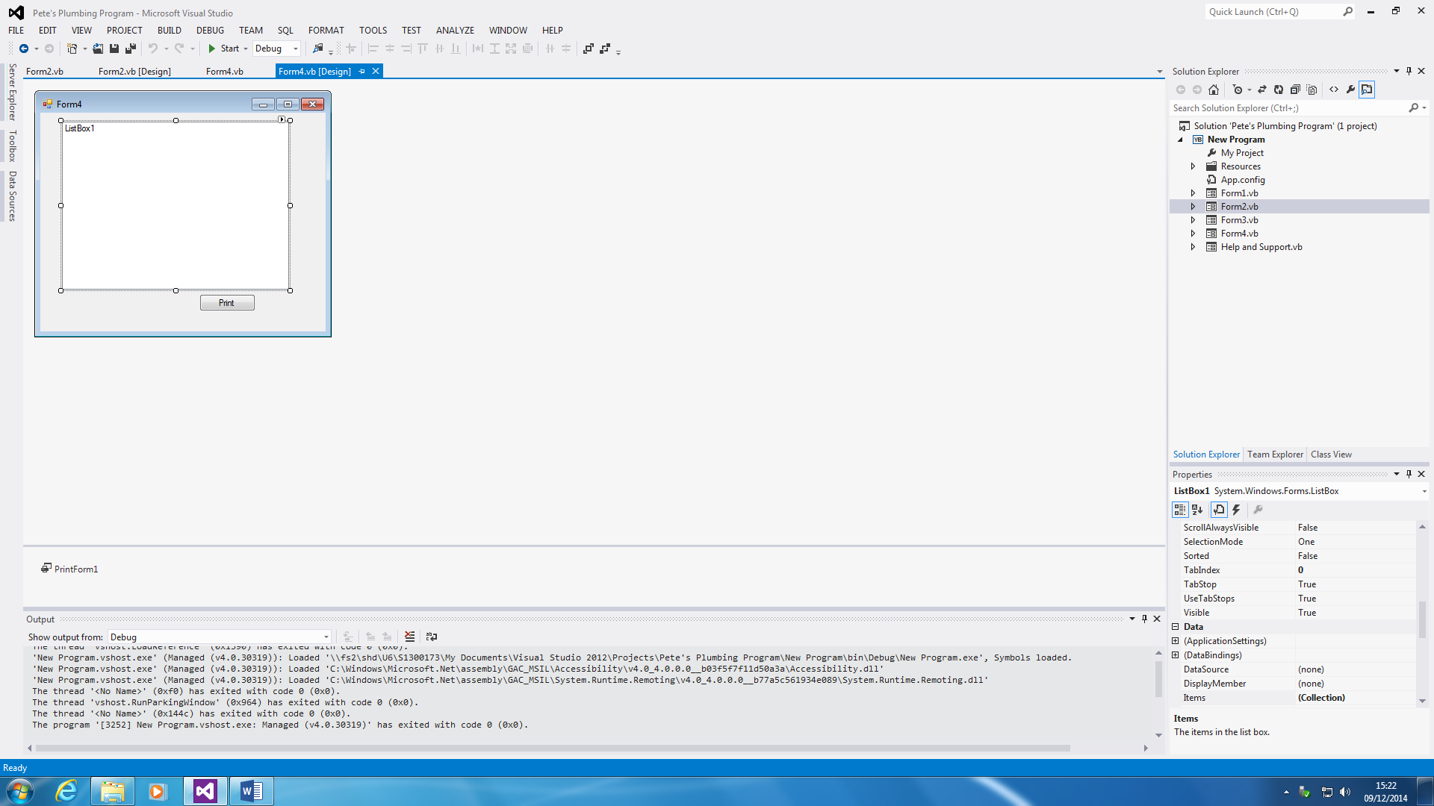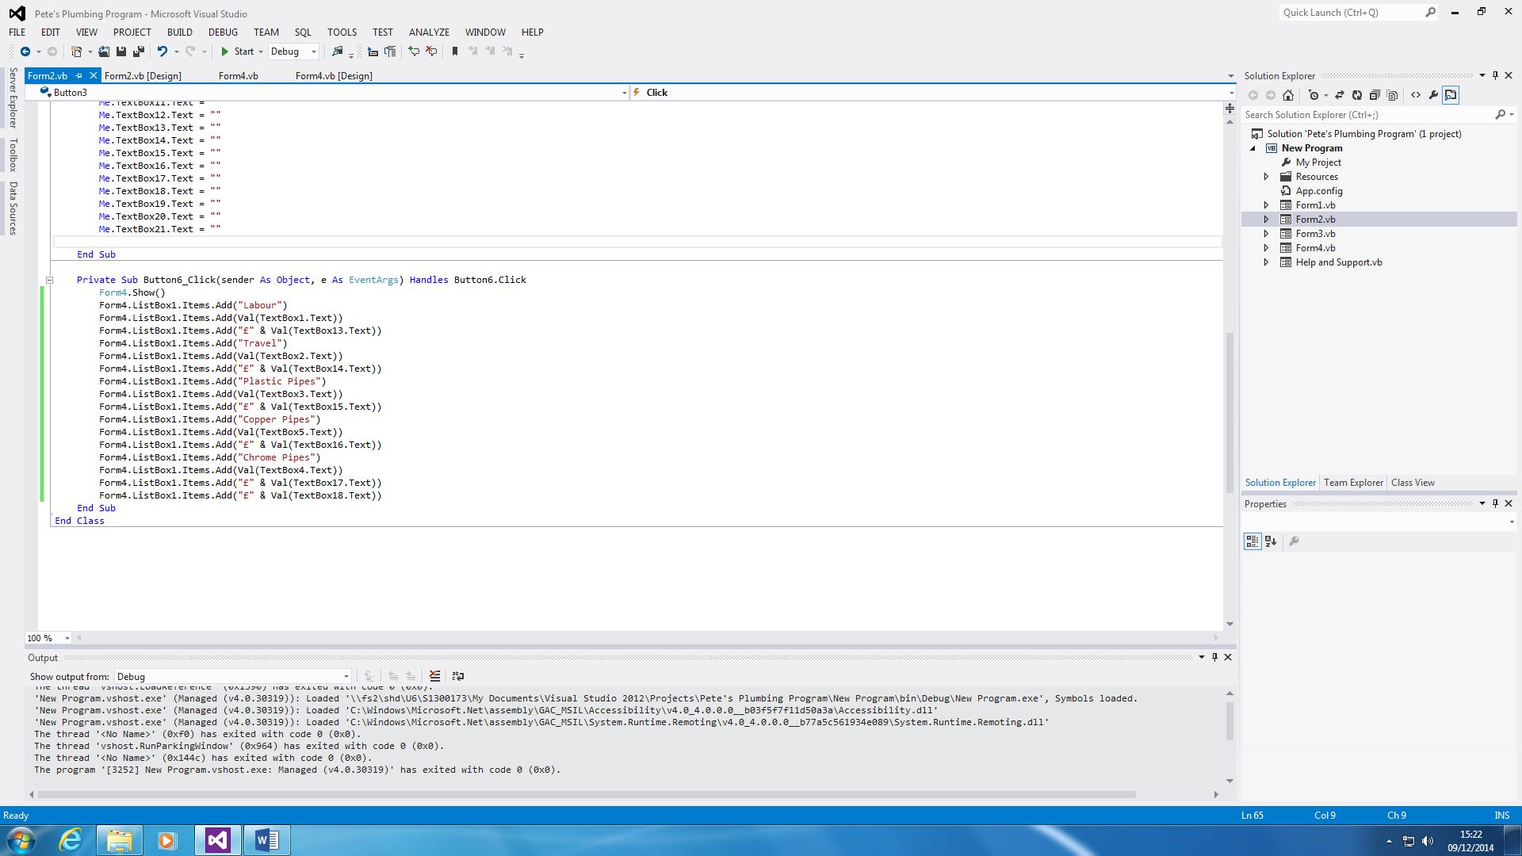

This shows a summary of the whole calculation. The user can print it out. The codes show that whatever has been inserted within the system, it adds it to the textbox and it prints it out if the user wants to print it out.

**Test plan**

|  |  |  |  |  |  |  |
| --- | --- | --- | --- | --- | --- | --- |
| **Test Number** | **Description** | **Test Type and Test Data** | **Expected Result** | **Actual Result** | **Pass or Fail?** | **Screenshot Reference** |
| **1** | Login Screen | **Valid**  **Username:** Usman123  **Password:**  Ranger | The expected result of the login screen is for the user to log in to the part where he/she wants to calculate something. |  |  |  |
| **2** | Produce correct calculations | **Extreme**  Inputs, for example, Labour. | The expected result of this is that it is supposed to add all the numbers that have been entered in the textboxes. |  |  |  |
| **3** | Button works | **Valid**  They need all of the other inputs to work | Checking if the button works. |  |  |  |
| **4** | Help and Support button | **Valid**  Guide showing user | Checking if the button clicks to show the user if he or she is stuck |  |  |  |
| **5** | Clear button | **Valid**  Clearing all Textboxes on the main form. | Does the clearing button clear all the textboxes? |  |  |  |
| **6** | Database | **Extreme**  Microsoft Access - Database | The expected result is for the database to be linked with the system, get information, and close. It has to insert it as well. |  |  |  |
| **7** | VAT | **Valid**  Total Cost + VAT (20%) | The expected result is for the overall cost to be added with the VAT |  |  |  |
| **8** | Quit Button | **Valid** | The expectation is that the calculation form closes. |  |  |  |